Pokhara University

Level: Bachelor | Semester – Spring | Year : 2005
Programme: BE |  | Full Marks : 100
Course: Probability and Statistics |  | Time : 3hrs.

Candidates are required to give their answers in their own words as far as practicable.
The figures in the margin indicate full marks.

Attempt all the questions.

1. | a) Define classification. Distinguish between exclusive and inclusive method of classification. The following data gives the marks obtained by the students in statistics. Represent the data by means of less than and more than Ogives. | 8
12 42 49 23 46 21 24 26 9 7 5 42 31
24 25 26 23 21 15 16 14 18 19 13 10 8
9 7 5 35 24 2 24 20 25 26 23 27 38
39 3 8 32 31 30 35 38 25 24 26 15 16
7 18 35 26 12 14 25 26 28 27 25 40 30
 | b) The mean weight of 150 students is 60 kg. The mean weight of boys is 70 kg with a standard deviation of 10kg. For the girls the mean weight is 55kg and a standard deviation is 15kg. Find the number of boys & girls and the combined standard deviation. | 7
2. | a) State and prove Bayes' theorem for conditional probability.  b) A problem in statistics is given to three students A, B and C whose chance of solving are 1/2, 1/3 and 1/4 respectively. Find the probability that:  i) All of them can solve the problem  ii) None of them can solve  iii) At least one of them will solve. | 7  8
3. | a) If 90% of all students taking a beginning computer programming course fail to get their first Program to run on first submission, what is the probability that among 15 randomly chosen such students:  i) at least 12 fail on first submission  ii) between 10 and 13 inclusive fail on first submission  iii) at most two get their program to run properly on first submission.  b) From a lot containing 25 items, 5 of which are defective, 4 are chosen at random. Obtain the probability distribution of the number of defective items drawn. Also find the probability of 3 or 4 defective items. | 8  7
4. | a) Define joint and marginal probability density functions. Two random variables X and Y have the following probability density function.  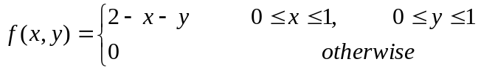  Find:  - marginal probability density functions of X and Y  - Conditional functions of X on Y and Y on X  - V(X) and V(Y)  - Covariance between X and Y  b) In a normal distribution, 31% of the items are under 45 and 8% are over 64. Find the Mean and Variance of the distribution. | 7  8
5. | a) A sample of 50 pieces of a certain type of string was tested. The mean breaking strength turned out to be 14.5 Kgs. Test whether the sample is from a batch of string having a mean breaking strength of 15.6 Kgs and standard deviation of 2.2 Kgs.  b) A company claims that the mean life time of its electric light bulb is 28 months. A random sample of 10 bulbs has the following life in month  24, 26, 32, 28, 20, 20, 23, 4, 30 and 43. Test the claim of the company at 5% level of significance and obtain 95% confidence limit for the population mean. | 7  8
6. | a) A population consist of the values 2, 5, 9, 14, 15 and 18. Prove by drawing all possible sample of size 3 without replacement that sample mean is an unbiased estimator of the population mean.  b) Given the following results for the height (X) and the weight (Y) in appropriate units of 100 students. 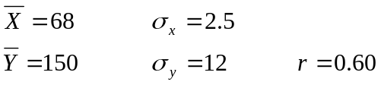  Obtain the equations of two lines of regression. Estimate the height of the student A whose weight is 200 units and also estimate the weight of the student B whose height is 60 units. | 8  7
7. | Define briefly the following (Any Five):  - Difference between correlation and regression  - Characteristics of Normal distribution  - Conditions for using t- test in hypothesis testing  - Point estimation  - Co-efficient of determination  - Statistics and parameter | 5x2

